

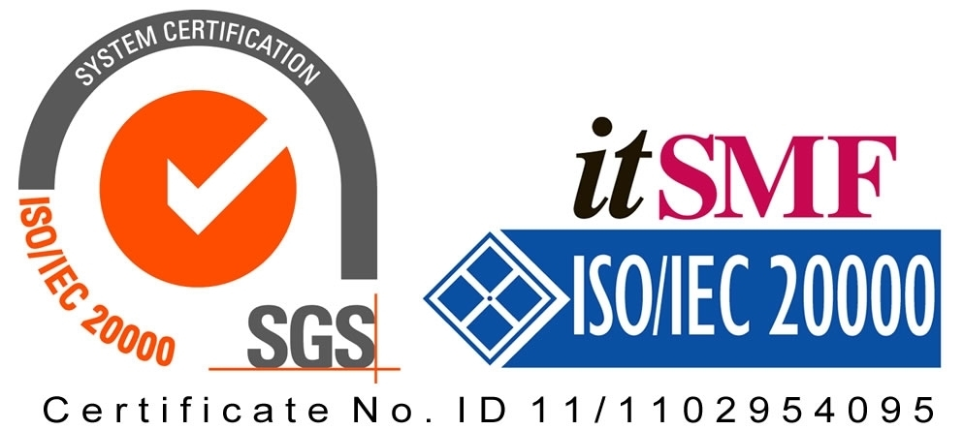

*Operating Lease Support System Development*

**For**



***Entity Relationship Diagram***

***DATA HISTORICAL***

Revision 0.0

**Prepared by:**

**PT. Berlian Sistem Informasi**

KTB Annex Bld. 4th Floor, Jl. Jend. A. Yani. Pulomas,

Tel. +62 21 4786 7575 (Hunting) Fax. +62 21 4714964 [www.bsi.co.id](http://www.bsi.co.id)

Document Control

|  |  |
| --- | --- |
| **Author** | ACHMAD FARDANI RIZKI |
| **File Name** |  |
| **Path** | N/A |
| **Create Date** |  |
| **Last Edited** |  |
| **Number of Pages** | 28 |

Revision History

|  |  |  |  |
| --- | --- | --- | --- |
| **Date** | **Revision** | **Description** | **Author** |
| 15-Apr-2015 | 0.0 | Initial creation | Achmad Fardani Rizki |

Distribution List

|  |  |  |
| --- | --- | --- |
| **Name** | **Organization** | **Title** |
| Mr. Jin Nishimura | Dipo Star Finance, PT | ~~DSF Project Director~~ |
| Mr. Abdul Somad | Dipo Star Finance, PT | ~~DSF Project Manager~~ |
| ~~Mr. Satoshi Koibuchi~~ | ~~Berlian Sistem Informasi, PT~~ | ~~BSI Project Director~~ |
|  | ~~Berlian Sistem Informasi, PT~~ | ~~BSI Project Manager~~ |

Document Approval

By signing this document I acknowledge I have read the document and give the Project Management Team approval to proceed.

|  |  |  |  |
| --- | --- | --- | --- |
| **Role** | **Name** | **Signature** | **Date** |
| DSF Project Director | Mr. Jin Nishimura |  |  |
| DSF Project Manager | Mr. Abdul Somad |  |  |
| ~~BSI Project Director~~ | ~~Mr. Satoshi Koibuchi~~ |  |  |
| ~~BSI Project Manager~~ |  |  |  |

Table of Contents

Document Control 2

Revision History 2

Distribution List 2

Document Approval 2

1 Introduction 4

1.1 Purpose 4

1.2 Scope 4

1.3 Acronyms and abbreviations 4

1.4 References 4

2 Database Relationship And Column Properties 5

2.1 Master Data Historical 5

**2.1.1** **Master Data Historical Diagram** 5

**2.1.2** **Database Column Properties** 5

2.1.2.1 Master_History 5

2.1.2.2 Master_History_Dtl 5

2.2 Transactional Data Historical 6

**2.2.1** **Calculation of Refinance Data Historical** 6

2.2.1.1 Calculation of Refinance Data Historical Diagram 6

2.2.1.2 Database Column Properties 7

**2.2.2** **Refinance Quotation Data Historical** 9

2.2.2.1 Refinance Quotation Data Historical Diagram 9

2.2.2.2 Database Column Properties 9

**2.2.3** **Operating Lease Calculation And Proposal Data Historical** 11

2.2.3.1 Operating Lease Calculation and Proposal Diagram 11

2.2.3.2 Database Column Properties 12

**2.2.4** **Operating Lease Quotation Data Historical** 17

2.2.4.1 Operating Lease Quotation Diagram 17

2.2.4.2 Database Column Properties 18

**2.2.5** **Agreement Data Historical** 19

2.2.5.1 Agreement Data Historical Diagram 19

2.2.5.2 Database Column Properties 20

**2.2.6** **Service History Data Historical** 23

2.2.6.1 Service History Data Historical Diagram 23

2.2.6.2 Database Column Properties 24

**2.2.7** **Billing & Payment History Data Historical** 27

2.2.7.1 Billing & Payment History Data Historical Diagram 27

2.2.7.2 Database Column Properties 27

1. Introduction
   1. Purpose

This document is addressed for the users whose privileges for manage the OLSS Application Data Historical.

* 1. Scope

This ERD is shows the relationships of entity sets, and also object of the entity.

* 1. Acronyms and abbreviations

[N/A]

* 1. References

[N/A]

1. Database Relationship And Column Properties
   1. Master Data Historical
      1. **Master Data Historical Diagram**

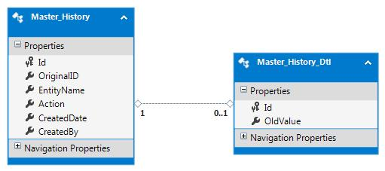

Figure 1 –diagram of Master Data Historical entities

Description of figure 1:

1. Master_History entity has one to a zero or one relationship with Master_History_Dtl entity, with Id as a reference
   * 1. **Database Column Properties**
        1. Master_History

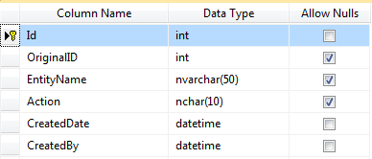

* + - 1. Master_History_Dtl

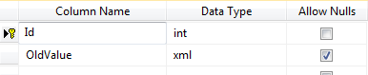

* 1. Transactional Data Historical
     1. **Calculation of Refinance Data Historical** 
        1. Calculation of Refinance Data Historical Diagram

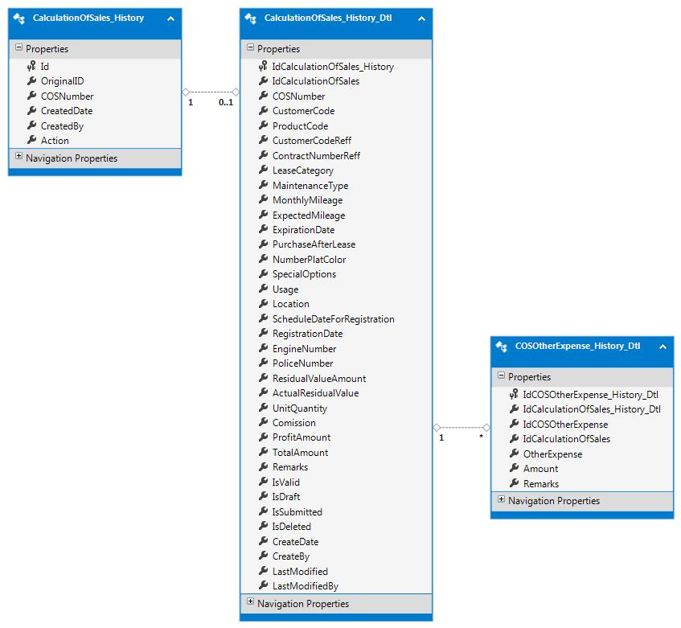

Figure 2–diagram of Calculation Of Refinance entities

Description of figure 2:

1. CalculationOfSales_History entity has one to zero or one relationship with CalculationOfSales_History_Dtl entity, with id as a reference.
2. CalculationOfSales_History_Dtl entity has one to many relationship with COSOtherExpense_History_Dtl entity, with IdCalculationOfSales_History as reference.
   * + 1. Database Column Properties
          1. CalculationOfSales_History

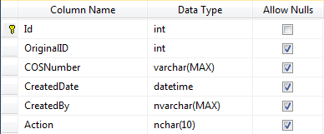

* + - * 1. CalculationOfSales_History_Dtl

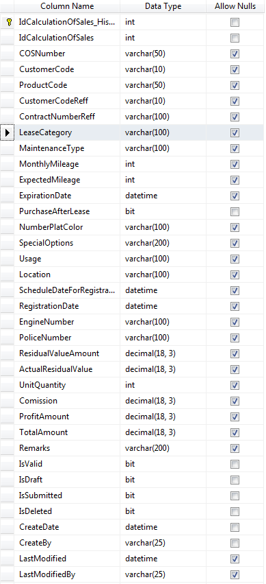

* + - * 1. COSOtherExpense_History_Dtl

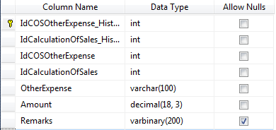

* + 1. **Refinance Quotation Data Historical**
       1. Refinance Quotation Data Historical Diagram

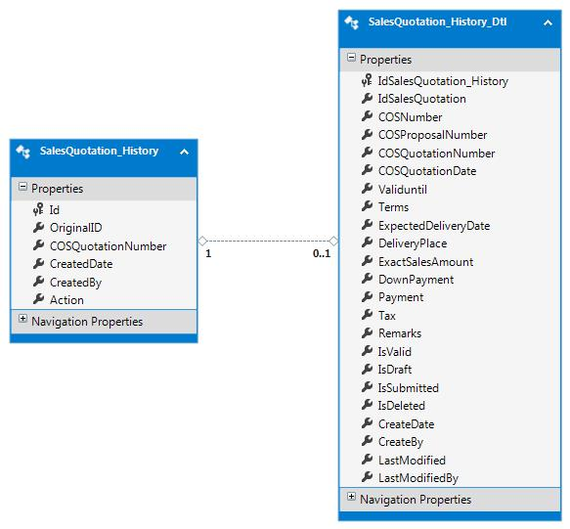

Figure 3–diagram of Refinance Quotation entities

Description of figure 3:

1. SalesQuotation_History entity has a one to zero or many relationship with SalesQuotation_History_Dtl, with Id as a reference.
   * + 1. Database Column Properties
          1. SalesQuotation_History

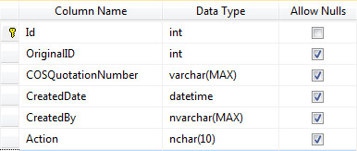

* + - * 1. SalesQuotationHistory_Dtl

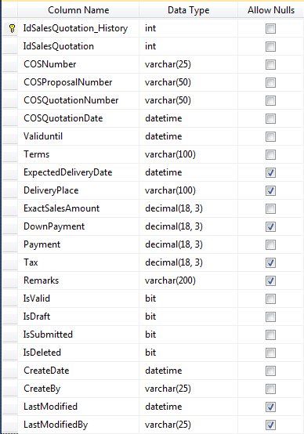

* + 1. **Operating Lease Calculation And Proposal Data Historical**
       1. Operating Lease Calculation and Proposal Diagram

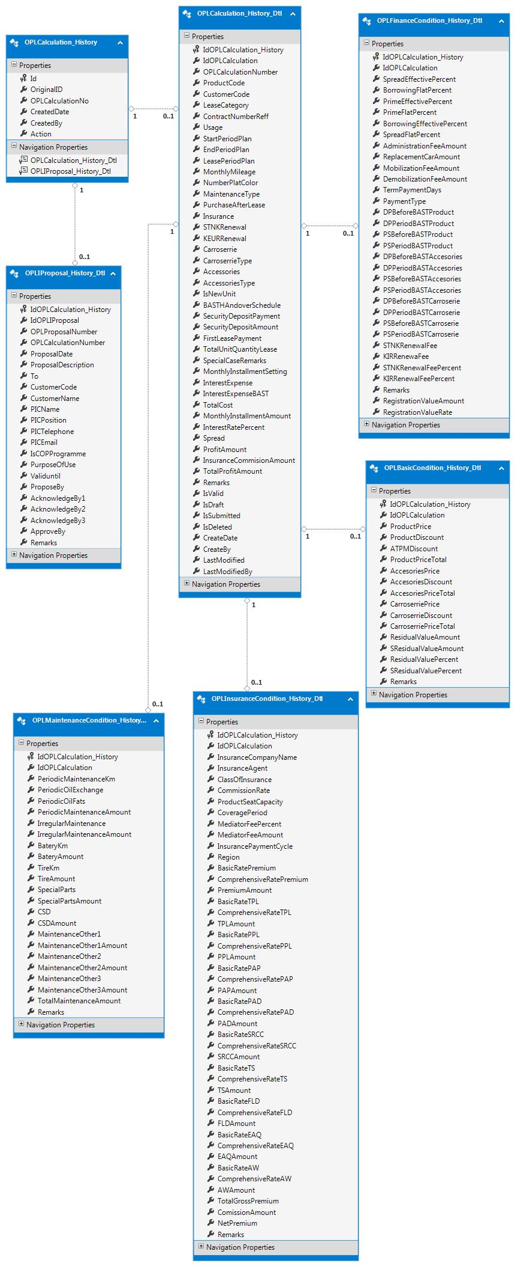

Figure 4–diagram of Operating Lease Calculation entities

Description of Figure 4:

1. OPLCalculation_History entity has one to zero or one relationship with OPLCalculation_History_Dtl, with id as reference
2. OPLCalculation_History entity has one to zero or one relationship with OPLIProposal_History_Dtl, with id as reference
3. OPLCalculation_History_Dtl entity has one to zero or one relationship with OPLBasicCondition_History_Dtl, with IdOPLCalculation_History as reference
4. OPLCalculation_History_Dtl entity has one to zero or one relationship with OPLFinanceCondition_History_Dtl, with IdOPLCalculation_History as reference
5. OPLCalculation_History_Dtl entity has one to zero or one relationship with OPLInsuranceCondition_History_Dtl, with IdOPLCalculation_History as reference
6. OPLCalculation_History_Dtl entity has one to zero or one relationship with OPLMaintenanceCondition_History_Dtl, with IdOPLCalculation_History as reference
   * + 1. Database Column Properties
          1. OPLCalculation_History

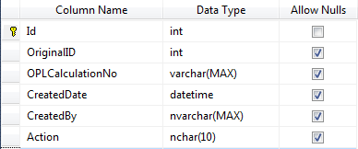

* + - * 1. OPLCalculation_History_Dtl

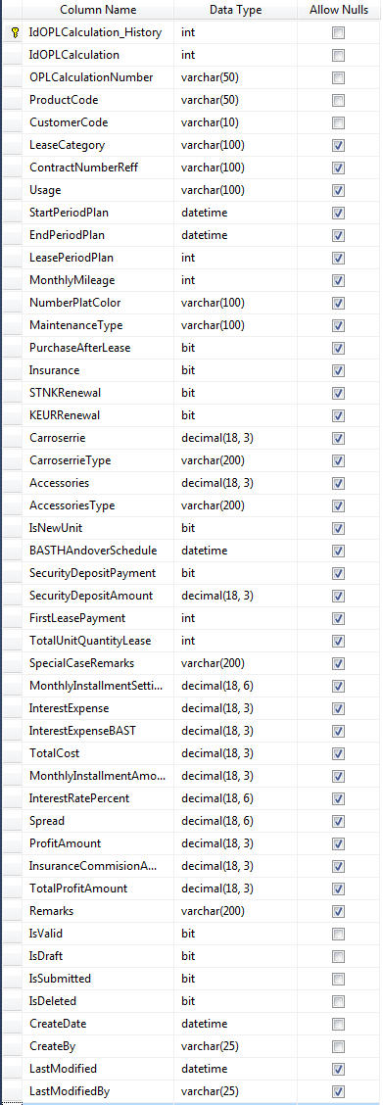

* + - * 1. OPLBasicCondition_History_Dtl

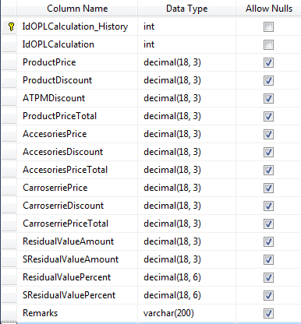

* + - * 1. OPLFinanceCondition_History_Dtl

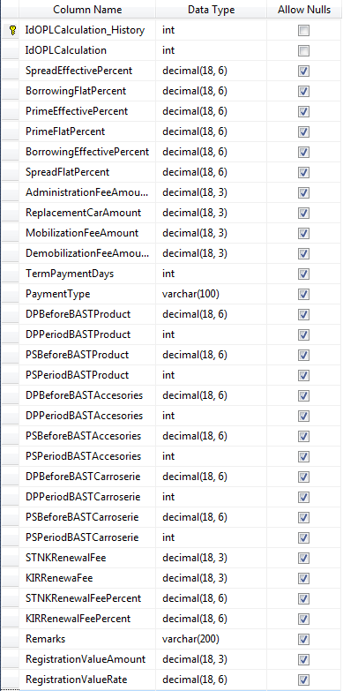

* + - * 1. OPLInsuranceCondition_History_Dtl

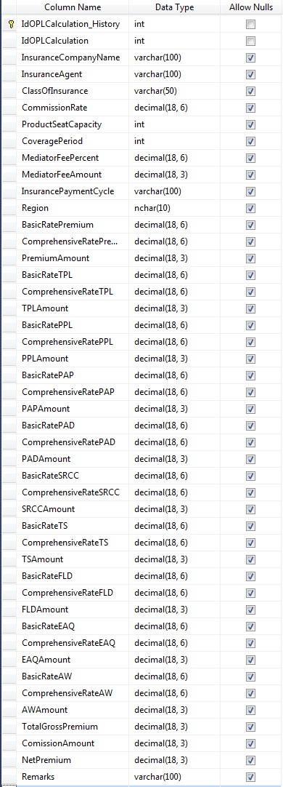

* + - * 1. OPLMaintenanceCondition_History_Dtl

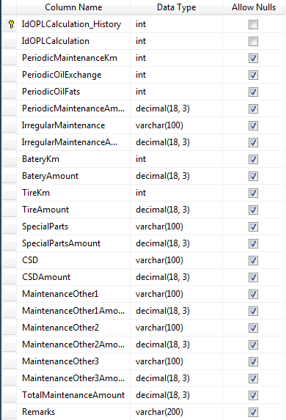

* + - * 1. OPLIProposalCondition_History_Dtl

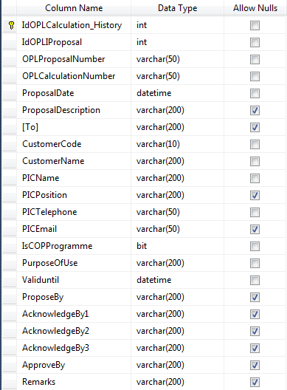

* + 1. **Operating Lease Quotation Data Historical**
       1. Operating Lease Quotation Diagram

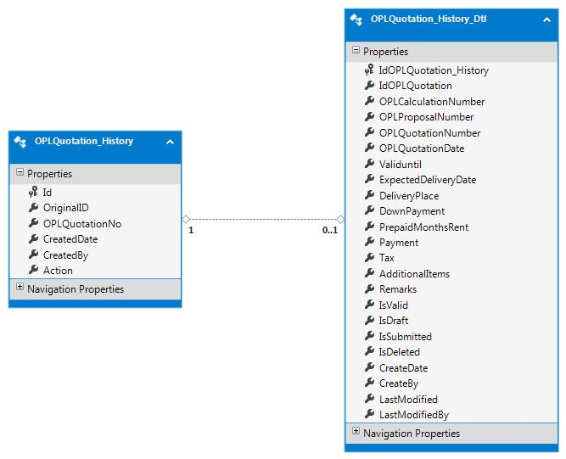

Figure 5–diagram of Operating Lease Quotation entities

Description of figure 5:

1. OPLQuotation_History entity has one to zero or one relationship with OPLQuotation_History_Dtl, with id as reference.
   * + 1. Database Column Properties
          1. OPLQuotation_History

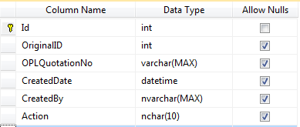

* + - * 1. OPLQuotation_Hostory_Dtl

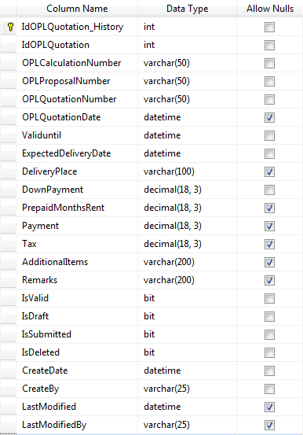

* + 1. **Agreement Data Historical**
       1. Agreement Data Historical Diagram

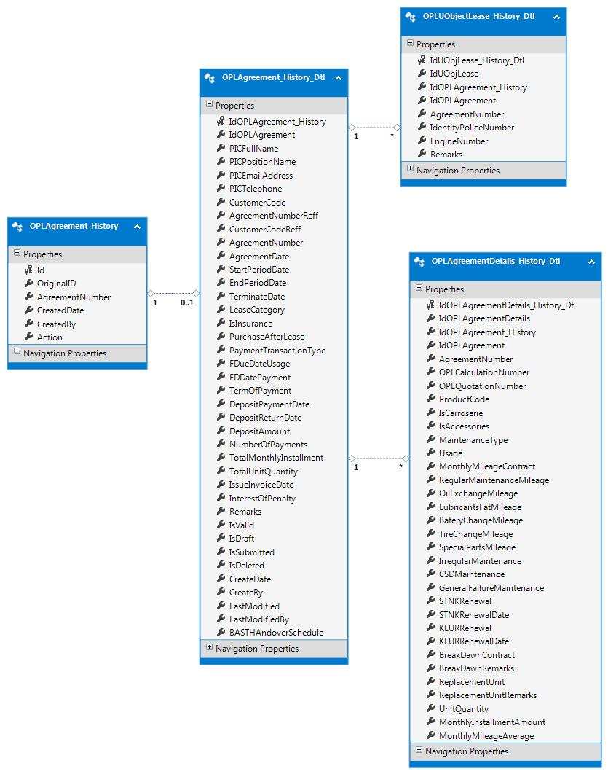

Figure 6 - diagram of Agreement entities

Description of Figure 6:

1. OPLAgreement_History entity has one to zero or one relationship with OPLAgreement_History_Dtl, with id as reference.
2. OPLAgreement_History_Dtl entity has one to many relationship with OPLAgreementDetails_History_Dtl, with IdOPLAgreement_History as reference.
3. OPLAgreement_History_Dtl entity has one to many relationship with OPLUObjectLease_History_Dtl, with IdOPLAgreement_History as reference.
   * + 1. Database Column Properties
          1. OPLAgreement_History

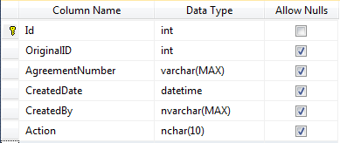

* + - * 1. OPLAgreement_History_Dtl

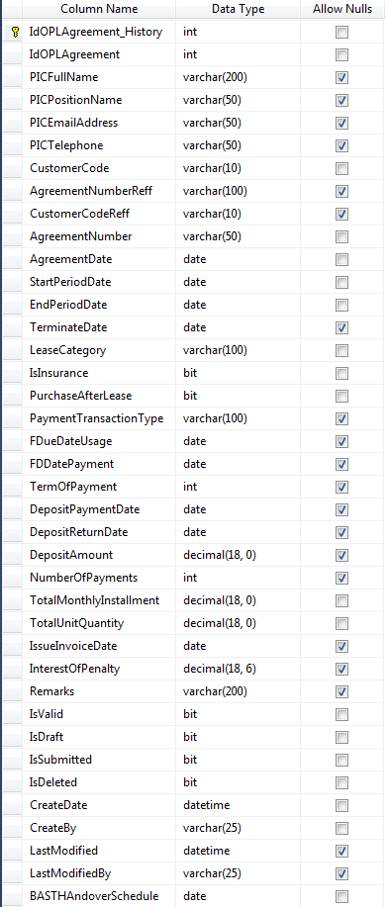

* + - * 1. OPLAgreementDetails_History_Dtl

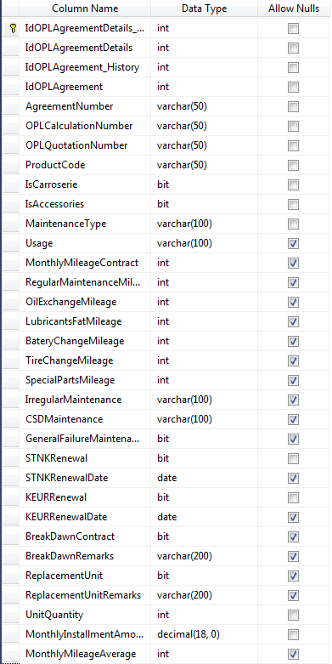

* + - * 1. OPLUObjectLease_History_Dtl

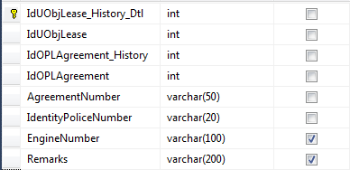

* + 1. **Service History Data Historical**
       1. Service History Data Historical Diagram

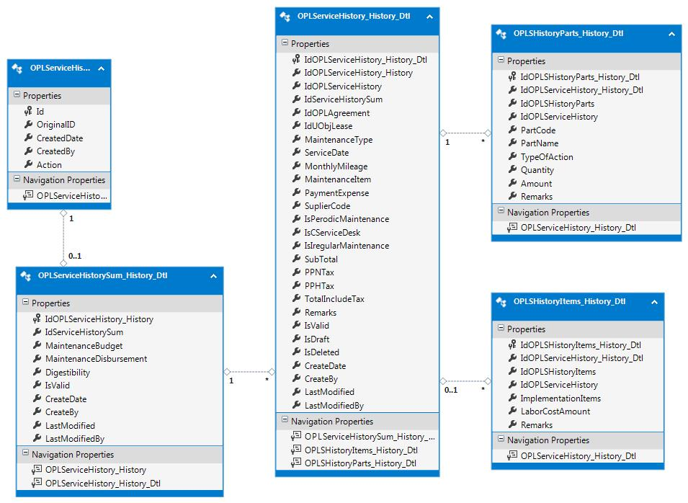

Figure 7- diagram of Service History entities

Description of Figure 7:

1. OPLServiceHistory_History entity has one to zero or one relationship with OPLServiceHistorySum_History_Dtl, with id as reference.
2. OPLServiceHistorySum_History_Dtl entity has one to many relationship with OPLServiceHistory_History_Dtl, with IdOPLServiceHistory_History as reference.
3. OPLServiceHistory_History_Dtl entity has one to many relationship with OPLSHistoryParts_History_Dtl, with IdOPLServiceHistory_History_Dtl as reference.
4. OPLServiceHistory_History_Dtl entity has one to many relationship with OPLSHistoryParts_History_Dtl, with IdOPLServiceHistory_History_Dtl as reference.
   * + 1. Database Column Properties
          1. OPLServiceHistory_History

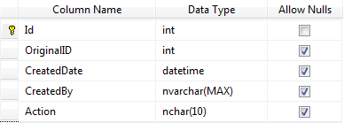

* + - * 1. OPLServiceHistorySum_History_Dtl

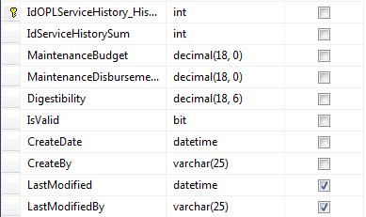

* + - * 1. OPLServiceHistory_History_Dtl

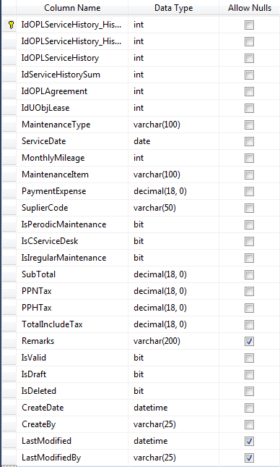

* + - * 1. OPLSHistoryParts_History_Dtl

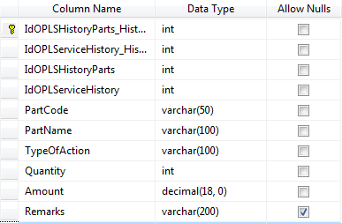

* + - * 1. OPLSHistoryItems_History_Dtl

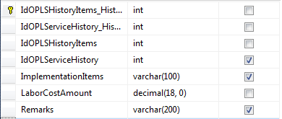

* + 1. **Billing & Payment History Data Historical**
       1. Billing & Payment History Data Historical Diagram

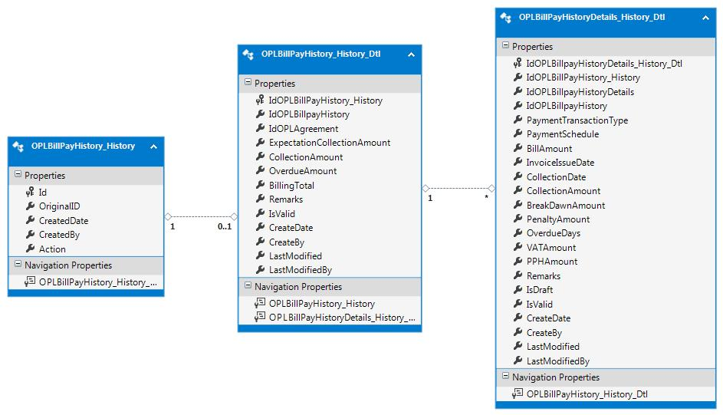

Figure 8- diagram of Billing & Payment History entities

Description of Figure 7:

1. OPLBillPayHistory_History entity has one to zero or one relationship with OPLBillPayHistory_History_Dtl, with id as reference.
2. OPLBillPayHistory_History_Dtl entity has one to many relationship with OPLBillPayHistoryDetails_History_Dtl, with IdOPLBillpayHistory_History as reference.
   * + 1. Database Column Properties
          1. OPLBillPayHistory_History

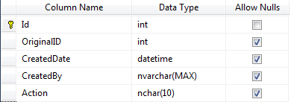

* + - * 1. OPLBillPayHistory_History_Dtl

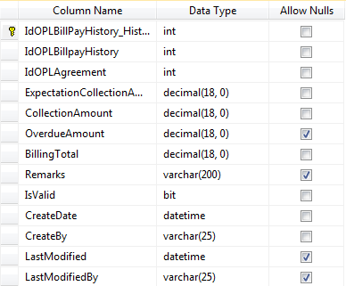

* + - * 1. OPLBillPayHistoryDetails_History_Dtl

